CprE 381 – Computer Organization and

Assembly-Level Programming

Proj-C Report

Lab Partners Chimzim Ogbondah & Parth

Section / Lab Time Section 4: Th 4:10-6pm

Submit a typeset pdf version of this on Canvas by the due date. Refer to the highlighted language in the Proj-C instructions for the context of the following questions.

- [Part 0] Come up with a global list of the datapath values and control signals that are required during each pipeline stage.

- [Part 1 (a)] Draw a simple schematic showing how you could implement stalling and flushing operations given an ideal N-bit register.

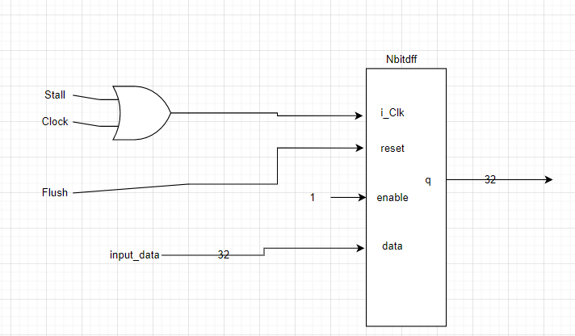

- [Part 1 (b)] Show that values that are stored in the initial IF/ID register are available as expected four cycles later, and that new values can be inserted into the pipeline every single cycle. [Please include waveforms and explanations.]

  - This waveform starts by only stalling the first register for one clock cycle it then puts in 1, 2,3,4 every cycle after. Finally, it inputs 5 but also stalls all the registers. Finally, every clock cycle it flushes IF/ID, then ID/EX, EX/MEM, MEM/WB
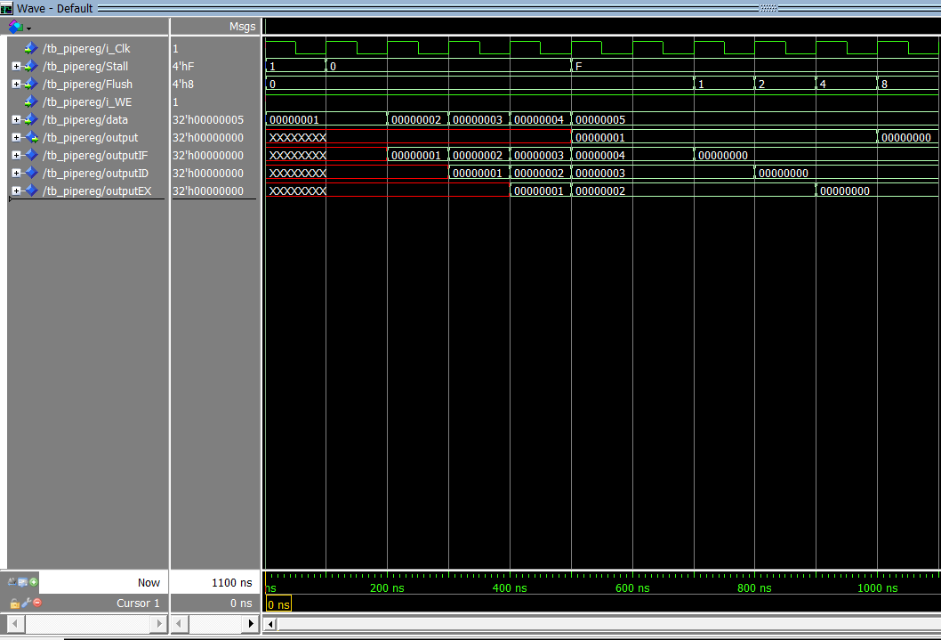

- [Part 2] In your writeup, provide your schematic for this part, describe what challenges (if any) you faced in implementing this module.
  - For all the pipeline registers the dff had to be altered to allow the right inputs to be taken in. This then had to be changed into a 32 bit register. The stall and Flush were set to zero and the write enable to 1. It wasn’t to hard implement the module but extra output signals had to be added since the pipeline registers were add. Note that Halt and V0 also go through the pipeline registers
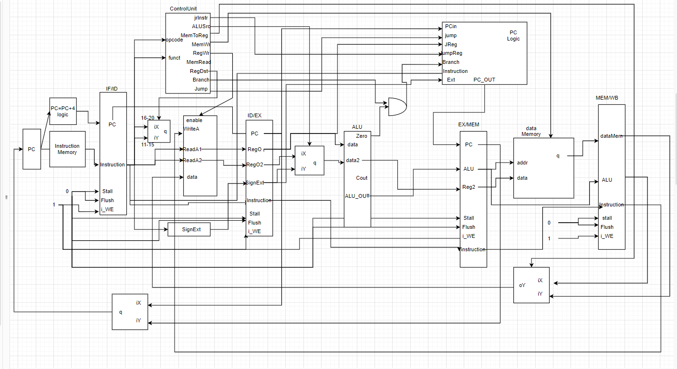

- [Part 3 (a)] In your writeup, show the ModelSim output for the individual instruction tests, and provide a discussion of result correctness. It may be helpful to also annotate the waveforms directly.

- [Part 3 (b)] In your writeup, show the ModelSim output for the modified Bubblesort test, and provide a discussion of result correctness. It may be helpful to also annotate the waveforms directly.

- [Part 4] Report the maximum frequency your software-scheduled pipelined processor can run at and determine what your critical path is (specify each module/entity/component that this path goes through).

  - The critical path is lw because it takes 5 cycles before the data would be ready. The lw instruction goes through all the components (IF/ID register -> registerfille -> ID/EX register -> ALU -> EX/MEM -> dataMemory -> MEM/WB -> registerfile) the data isn’t ready until after the dataMemory unit and MEM/WB register where it is then written into the registerfile

- [Part 5 (a)] Of the MIPS instructions supported for Project Part B, list which instructions produce values, and what signals in the pipeline these correspond to.

  - Add, addi, addu, and, andi, lw, nor, xor, xori, or, ori, slt, slti, sltu,sll, srl, sra, sllv, srlv, srav, sw, sub, subu, jr

- [Part 5 (b)] List which of these same instructions consume values, and what signals in the pipeline these correspond to.
  - All the R type instructions (ALU and Barrel shifter) and I type instructions
  - Control signals that correspond with a High value(1) are : RegWr, ALUsrc, datapath for barrel shifter, RegDst

- [Part 5 (c)] Come up with a generalized list of potential data dependencies. From this generalized list, select those dependencies that will require forwarding (write down the corresponding pipeline stages that will be forwarding and receiving the data), and those dependencies that will require hazard stalls.
  - RAW (Read after Write)
    - This will require forwarding because the next instruction is attempting to read the results of the destination register before they are ready. The EX/MEM register holds the output of the ALU which would be written back into the register file so the ALU from that register would need to be forwarded to after the ID/EX register to a mux where based on if it is the Rt or Rs register it would be forwarded to the correct place.

- [Part 6] Write a more generalized series of data forwarding and hazard detection logic equations based on the result from part 5).

- [Part 7] Provide a high-level schematic drawing of the interconnection between components for the MIPS Hardware-scheduled pipelined Processor.

- [Part 8 (a)] In your writeup, show the ModelSim output for the individual instruction tests and Bubblesort test (the original from Project Part B), and provide a discussion of result correctness. It may be helpful to also annotate the waveforms directly.

- [Part 8 (b)] In your writeup, show the ModelSim output an application that attempts to exhaustively test the forwarding and detection logic in your pipeline, and provide a discussion of result correctness. It may be helpful to also annotate the waveforms directly.

- [Part 10] Report the maximum frequency your processor can run at and determine what your critical path is. Draw this critical path on top of your top-level schematic. In your writeup, briefly discuss your critical path results. What components would you focus on to improve the frequency?

- [Feedback] You must complete this section for your lab to be graded. Please complete each column separately for each team member; I expect it to take roughly 10 minutes (do not take more than 20 minutes).

  - How many hours did you spend on this lab?

Task | During lab time |  |  | Outside of lab time
Team Initials |  | co |  |  | co
Reading lab |  | .2 |  |  | .5
Pencil/paper design |  | .3 |  |  | 2.0
VHDL design |  | 4 |  |  | 2.0
Assembly coding |  | 0 |  |  | 1.0
Simulation |  | .5 |  |  | 1.0
Debugging |  | 0 |  |  | .5
Report writing |  | 0 |  |  | 1.0
Other: |  | 0 |  |  | 0
Total |  | 5 |  |  | 7.5

  - If you could change one thing about the lab experience, what would it be? Why?
    - More time really felt like the end of the semester came fast and we had to rush through this project not only because there was not enough time. Also, because we had other finals and projects for other classes which did not allow my lab partner and I to really give this project the attention it needed.

  - What was the most interesting part of the lab?
    - Figuring out how to stop the pipeline registers

